# Grazioso Salvare Dashboard

## About Animal Dashboard

The objective of this project is to create a user-friendly dashboard with filtering options to allow the dashboard to be filtered based rescue types. It implements the fundamental operations of creating and reading documents in Python using PyMongo to create CRUD functional access to the animal collection on the AAC database and Dash to create HTML elements.

## Motivation

The motivation behind this project is to design an application that displays a graph and table that allows for filtering of animal data. Through this application, the database can be accessed so that animals in the animal shelter can be displayed to the user and easily filtered. Overall, this system is designed to interact with a non-relational database to allow users to filter the animal data and use it to categorize the animals based on selected filters.

## Getting Started

To get this project set up locally is just a few steps. Assuming the mongodb database is already set up, the first step would be to download the .py file and the. ipynb file. Once loaded, change the port number to the port you’re looking to use as well as changing the database to the database you are using. If your using database AAC, then the only thing that needs changing is the port. Once the port is changed, run the ipynb file and it generate the full program.

## Installation

**Jupyter Notebook** - Download Anaconda. We recommend downloading Anaconda's latest Python 3 version (currently Python 3.5). Install the version of Anaconda which you downloaded, following the instructions on the download page. Congratulations, you have installed Jupyter Notebook. <https://test-jupyter.readthedocs.io/en/latest/install.html>

**Python** - Step 1 − Select Version of Python to Install, Step 2 − Download Python Executable Installer, Step 3 − Run Executable Installer, Step 4 − Verify Python is installed on Windows, Step 5 − Verify Pip was installed <https://www.tutorialspoint.com/how-to-install-python-in-windows>

**MongoDB** - Download the installer, Run the MongoDB installer, Follow the MongoDB Community Edition installation wizard. <https://www.mongodb.com/docs/manual/tutorial/install-mongodb-on-windows/>

**PyMongo** – Install using pip. <https://pymongo.readthedocs.io/en/stable/installation.html>

**Modules**

**PyMongo –** This is the module that is chosen to interface between the Python scripts and the MongoDB database. This driver is the recommended way to interface with mongo through Python and PyMongo is the official native driver for MongoDB. With PyMongo it is easy to use MongoDB documents and maps directly MongoDB Query Language. This familiar style of query language allows for the use of CRUD functions,( Create, Read, Update, Delete), with the database. <https://www.mongodb.com/compatibility/mongoengine-pymongo>

**DASH –** This module is used to generate the HTML elements using python.

<https://dash.plotly.com/introduction>

## Usage

### Code Example

Here the code adds the radio buttons that would be used to filter the table.

Code for the interactive filtering options, Radio buttons.

### Example Query

Example of the query that is used to search the database for filtered animals.

df = pd.DataFrame(list(shelter.readDataBase({"animal_type":"Dog","breed":

{"$in":["Labrador Retriever Mix",

"Chesapeake Bay Retriever",

"Newfoundland"]},

"sex_upon_outcome":"Intact Female",

"age_upon_outcome_in_weeks":{"$gte":26},

"age_upon_outcome_in_weeks":{"$lte":156}})

))

### Images of program operation

Program Title, Unique Identifier, and Logo

Image of Dashboard before any filtering

Image of Pie Graph and Geolocation Map

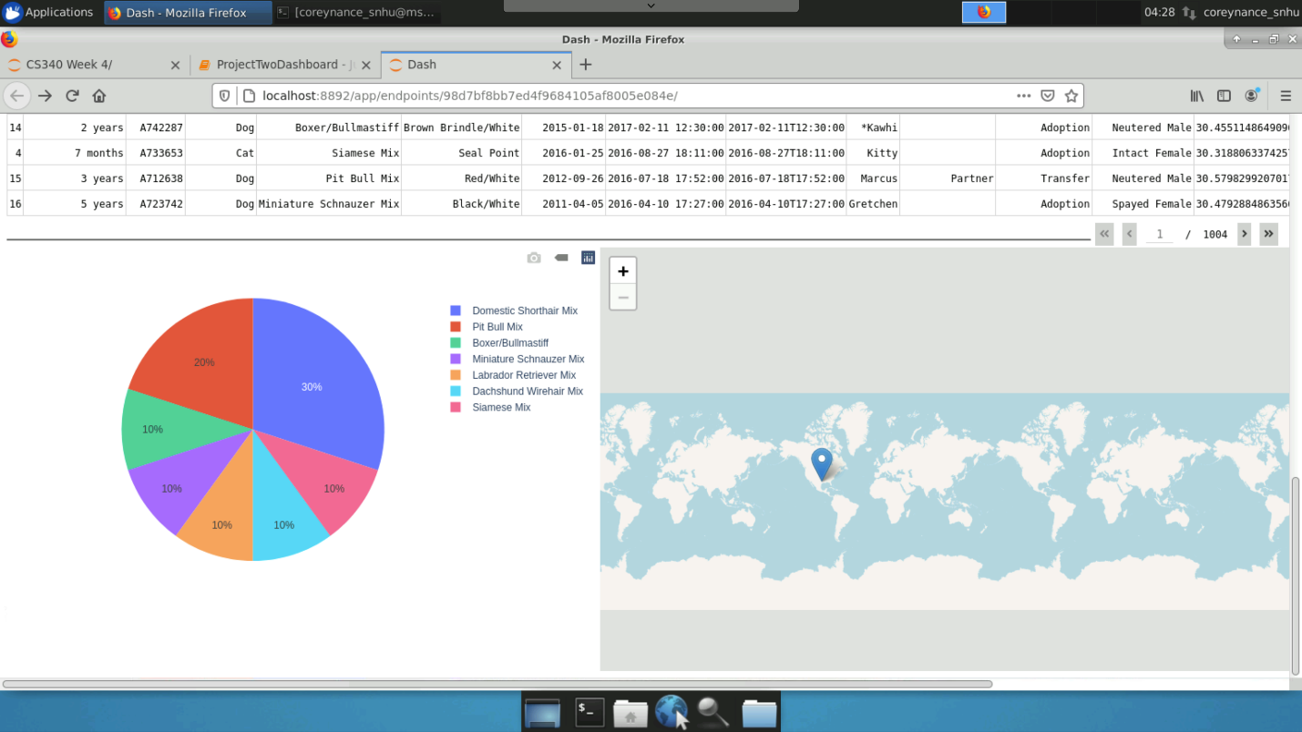

Image of Logo link working

**

Image of Water Rescue filter operation

Image of Mountain Rescue filter operation

Image of Disaster Rescue filter operation

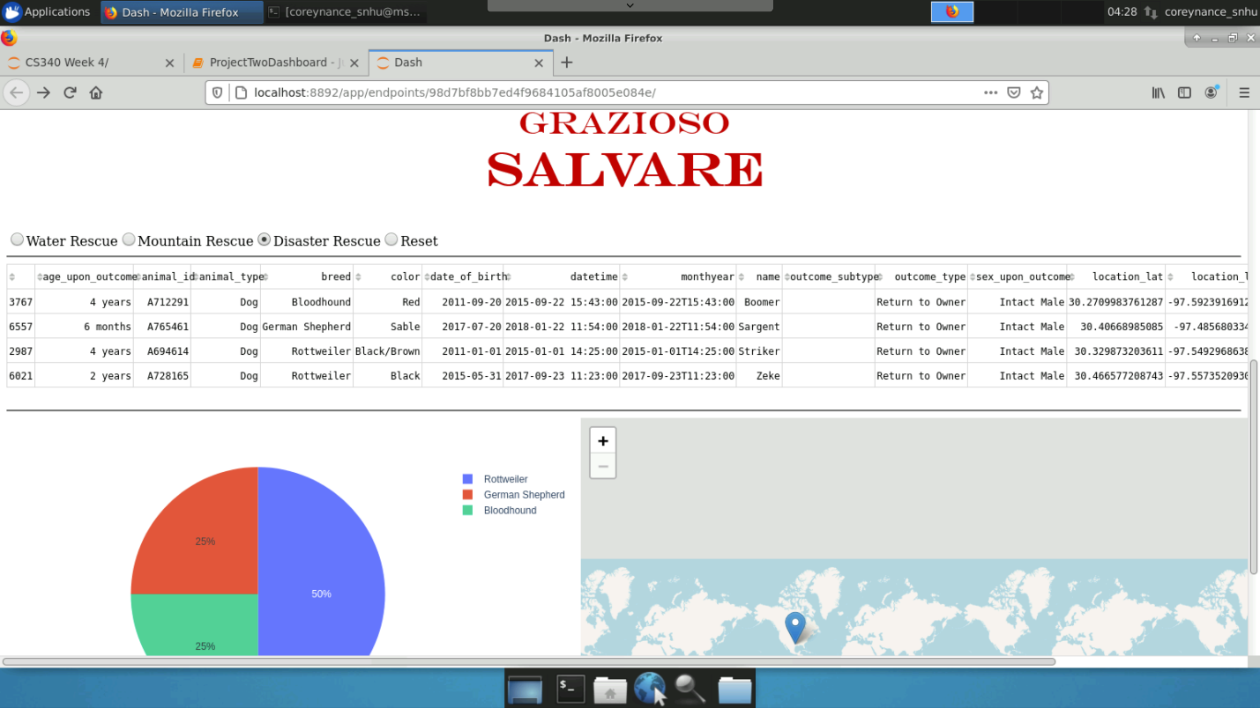

Image of Reset filter operation

## Video and Link Program operation



<https://youtu.be/didnicbl-iQ>

## Contact

Your name: Corey Nance